Technologies Used in Mobile Networks

📶 What Are the Technologies Used in Mobile Networks?
# Source: AI Source: Provided by: [Data Path: Persons Table -> ID Column: 1, Name_En Column: Motasem Essam] -> From: [ChatGPT] on [1/23/2026]
Mobile networks rely on a combination of radio, digital, and networking technologies to allow phones and other devices to connect wirelessly for calls, text, and data. These technologies are organized into generations (1G to 5G) and include many components working together.

🧱 1. Network Generations (G)
# Source: AI Source: Provided by: [Data Path: Persons Table -> ID Column: 1, Name_En Column: Motasem Essam] -> From: [ChatGPT] on [1/23/2026]
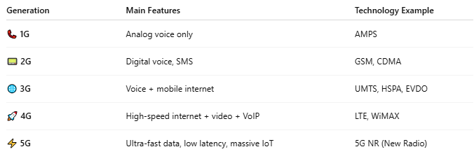
Generation | Main Features | Technology Example
📞 1G | Analog voice only | AMPS
📟 2G | Digital voice, SMS | GSM, CDMA
🌐 3G | Voice + mobile internet | UMTS, HSPA, EVDO
🚀 4G | High-speed internet + video + VoIP | LTE, WiMAX
⚡ 5G | Ultra-fast data, low latency, massive IoT | 5G NR (New Radio)

🛰️ 2. Radio Access Technologies (RAT)
# Source: AI Source: Provided by: [Data Path: Persons Table -> ID Column: 1, Name_En Column: Motasem Essam] -> From: [ChatGPT] on [1/23/2026]
These technologies connect devices to the radio part of the network (cell towers):
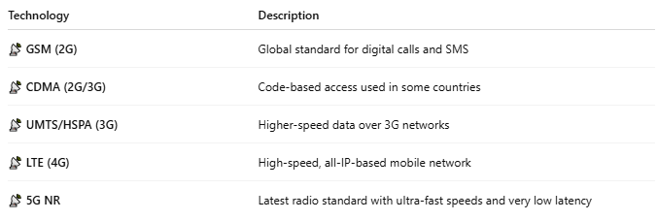
Technology | Description
📡 GSM (2G) | Global standard for digital calls and SMS
📡 CDMA (2G/3G) | Code-based access used in some countries
📡 UMTS/HSPA (3G) | Higher-speed data over 3G networks
📡 LTE (4G) | High-speed, all-IP-based mobile network
📡 5G NR | Latest radio standard with ultra-fast speeds and very low latency

🌐 3. Core Network Technologies
# Source: AI Source: Provided by: [Data Path: Persons Table -> ID Column: 1, Name_En Column: Motasem Essam] -> From: [ChatGPT] on [1/23/2026]
These manage routing, switching, identity, and billing:

Component | Function
🧠 MSC | Mobile Switching Center – routes voice calls
🌐 EPC | Evolved Packet Core – used in LTE
💠 5GC | 5G Core – software-defined, fast, cloud-ready
🔐 HLR/HSS | Stores user identity and SIM information
💳 PCRF | Controls QoS and data usage policies

🧭 4. Wireless Communication Technologies
# Source: AI Source: Provided by: [Data Path: Persons Table -> ID Column: 1, Name_En Column: Motasem Essam] -> From: [ChatGPT] on [1/23/2026]
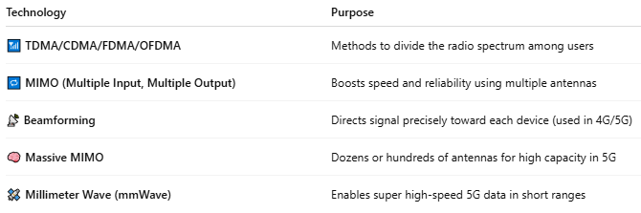

Technology | Purpose
📶 TDMA/CDMA/FDMA/OFDMA | Methods to divide the radio spectrum among users
🔁 MIMO (Multiple Input, Multiple Output) | Boosts speed and reliability using multiple antennas
📡 Beamforming | Directs signal precisely toward each device (used in 4G/5G)
🧠 Massive MIMO | Dozens or hundreds of antennas for high capacity in 5G
🛰️ Millimeter Wave (mmWave) | Enables super high-speed 5G data in short ranges

📡 5. Backhaul and Transport
# Source: AI Source: Provided by: [Data Path: Persons Table -> ID Column: 1, Name_En Column: Motasem Essam] -> From: [ChatGPT] on [1/23/2026]
Connects cell towers to the core network:
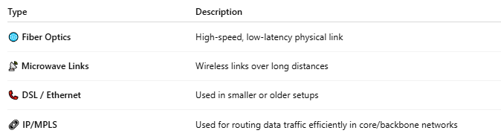

Type | Description
🌐 Fiber Optics | High-speed, low-latency physical link
📡 Microwave Links | Wireless links over long distances
📞 DSL / Ethernet | Used in smaller or older setups
🔗 IP/MPLS | Used for routing data traffic efficiently in core/backbone networks

🧠 6. Security & Identity
# Source: AI Source: Provided by: [Data Path: Persons Table -> ID Column: 1, Name_En Column: Motasem Essam] -> From: [ChatGPT] on [1/23/2026]
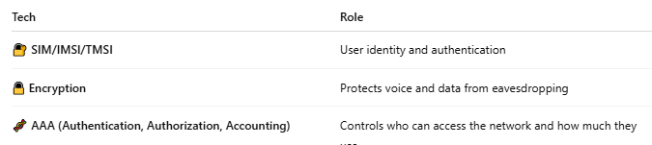

Tech | Role
🔐 SIM/IMSI/TMSI | User identity and authentication
🔒 Encryption | Protects voice and data from eavesdropping
🧬 AAA (Authentication, Authorization, Accounting) | Controls who can access the network and how much they use

📖 Summary: Key Mobile Network Technologies
# Source: AI Source: Provided by: [Data Path: Persons Table -> ID Column: 1, Name_En Column: Motasem Essam] -> From: [ChatGPT] on [1/23/2026]
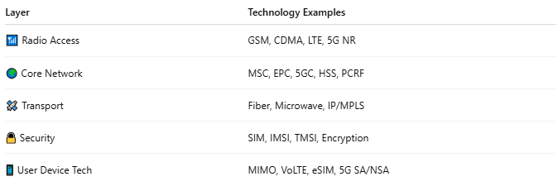
Layer | Technology Examples
📶 Radio Access | GSM, CDMA, LTE, 5G NR
🌍 Core Network | MSC, EPC, 5GC, HSS, PCRF
🛰️ Transport | Fiber, Microwave, IP/MPLS
🔒 Security | SIM, IMSI, TMSI, Encryption
📱 User Device Tech | MIMO, VoLTE, eSIM, 5G SA/NSA

